Alexander Dickson Primary School (4013046)
3-Year Strategic Overview
2025-2028
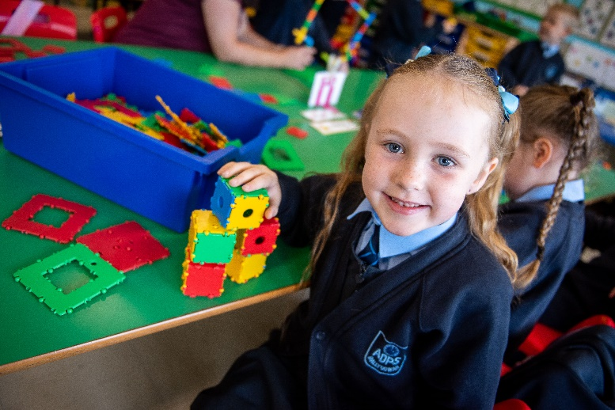
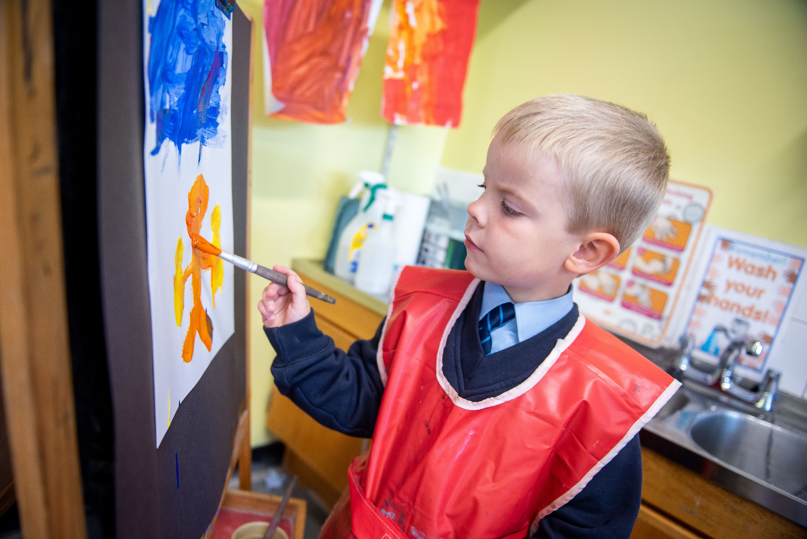



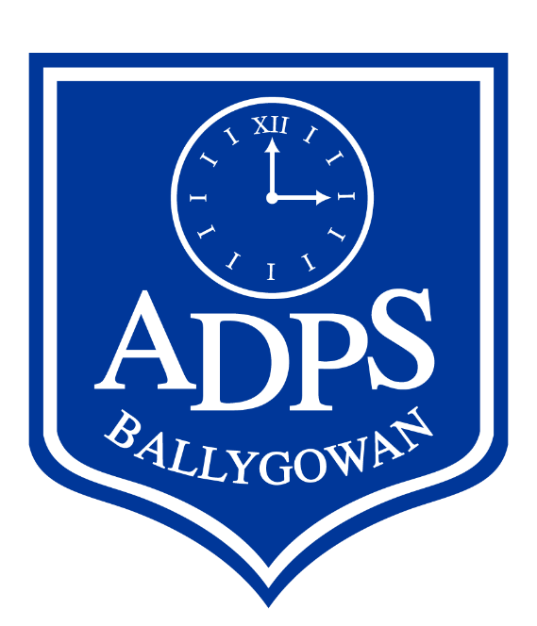


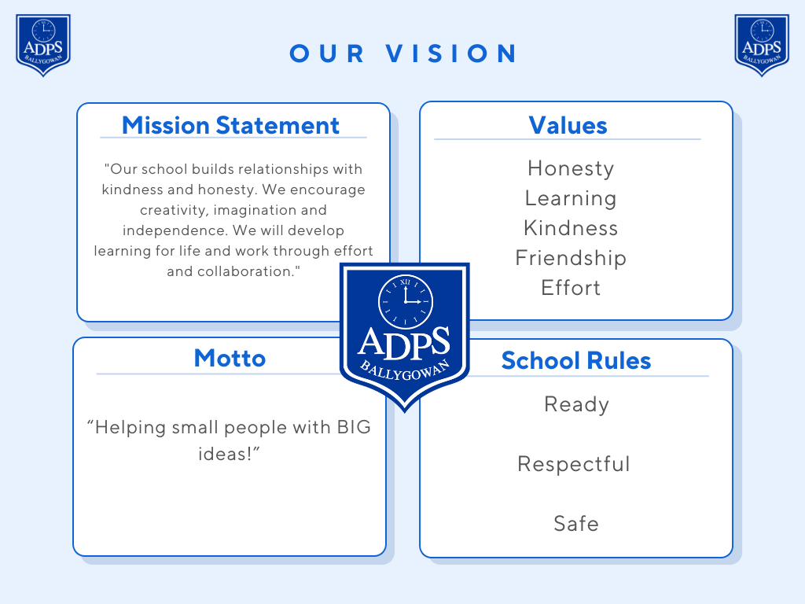
Contents
Section | Page
Chairperson’s Introduction | 4
Setting the Scene: Our Context | 5

5 Core Questions
Question 1: What is the school’s/organisation’s vision and what informs it? | 9
Question 2: How is the school/organisation setting about achieving the vision, within its own context? | 10
Question 3: How does the school/organisation monitor how well it and its learners are doing and how responsive is it to overcoming challenges and barriers? | 12
Question 4: How does the school/organisation define, celebrate and embed success for all learners? | 13
Question 5: How is the school/organisation creating the right conditions for the growth and development of a community of learning? | 14

Evidence
Stake Holder Engagement | 15
Data | 20
ETI Inspection Feedback (2024) | 23

Priorities
Priorities | 24
Summary of Planned Actions | 25
Low Level Priorities / Quick Wins | 27

Chairperson’s Introduction

Introduction from the Chair of Governors

At Alexander Dickson Primary School, we believe in helping small people with big ideas.

Our school is a nurturing and empowering environment where every child is encouraged to embrace their best future. We are committed to ensuring that all pupils feel safe, valued and inspired to reach their full potential—both now and in the years ahead.

Our mission is clear:
"Our school builds relationships with kindness and honesty. We encourage creativity, imagination and independence. We will develop learning for life and work through effort and collaboration."

This Strategic Overview reflects our inclusive, non-denominational Christian ethos. It translates our values of Honesty, Learning, Kindness, Friendship and Effort into action by setting out a forward-thinking, excellence-driven vision for our school community.

The plan has been shaped by the Education and Training Inspectorate’s (ETI) five Core Questions, which have guided our self-evaluation and community engagement. We are proud of the positive outcome of our 2024 ETI Inspection, and this Strategic Overview, along with associated Action Plans, builds on those strengths.

The Board of Governors formally ratified this plan in September 2025. We would like to extend our sincere thanks to the staff for their dedication and hard work in developing it. We also deeply appreciate the contributions of parents, carers, and community partners, whose insights—shared through surveys —have been invaluable.

Most importantly, we thank our pupils. Their voices, especially those of our School Council, were thoughtful, inspiring, and central to shaping this plan.

Kind regards,
Mr Les Fergus
Chairperson of the Board of Governors

Setting the Scene: Our Context
The following information details the current position of Alexander Dickson Primary School.
Enrolment | 88
Intake 2025 | 15 | Admissions number = 21
Attendance | 93.2% in 24/25 | In 2024/2025 there were 6 pupils with an attendance of less than 85%. Of these, 1 pupil left under Elective Home Education, 1 transferred to another primary school and 1 has been given a place in a specialist setting from September 2025.  Average attendance is increasing:  Average attendance over last 4 years
  24/25 | 23/24 | 22/23 | 21/22
  93.2% | 92.1% | 90.5% | 89.9%
Newcomer | 0% | There are no newcomers
FSME | 29% | 26 pupils are entitled to Free School Meals currently. We do not expect this to change i.e. no outstanding applications
SEND |  | - 26 pupils out of 81 (32%) are on the SEND Code of Practice, of which:  - 9 pupils are Stage 3 (3 going through the Statementing process)  - 0 pupils are Stage 2  - 18 pupils are Stage 1
Attainment | 96  65%  32%  95  53%  40%  214  178 | PTE whole school average score  Pupil progress is Expected, Higher than Expected or Much Higher than Expected  Pupils with low attainment  PTM whole school average score  Pupil progress is Expected, Higher than Expected or Much Higher than Expected  Pupils with low attainment  2024 - SEAG average score (for the first cohort of pupils to sit the new test format); 7 pupils sat the assessment; 57% of pupils were placed in Band 1; highest score 253  2025 – SEAG average score; 4 pupils sat the assessments highest score 194
Staffing / Class Organisation |  | Currently 3 full time teachers (including the teaching Principal) and 3 part-time teachers across 4 classes; in addition, there is 1 part-time learning support teacher  P1: Mrs Myrtle Muirhead (full-time and also Senior Teacher)  P2/3: Mrs Debbie McCullough (Mon-Tue and alt. Wed) and  Mrs Mandy Nield (alt.Wed, Thurs and Fri)  P4/5: Mrs Shannon Fee (full-time) - currently on maternity leave; class covered by Miss Lynsey Wightman until Easter 2026  P6/7: Mrs Claire Farquhar (Mon-Tues) and Mrs Laura Shaw (Wed-Fri)  Learning Support: Mrs Claire Farquhar (Wed-Thurs)  The Principal, Mrs Laura Shaw, was appointed in September 2025.  There is 1 general assistant for P1/2 and 7 SEN classroom assistants.  There is 1 Executive Officer (Mrs McKaig) who works 8.45am-1.45pm daily and 1 building supervisor and cleaner (Mrs McClure) who works a split shift daily (7.45am-9.45am and 2pm-5pm).  There is 1 catering assistant (Mrs Brown) who is employed by EA Catering, based at Saintfield Central Kitchen (remove bracket).
Accommodation |  | The school has committed to refurbishing one classroom every summer with the most recent being the P6/7 classroom. This included repainting and replacement of children’s desks and other furniture.  A new library opened in 2022 and a new garden area was opened in 2024.  Ballygowan Community Preschool has operated from the school’s grounds since 2011.  A shared outdoor play area with the preschool was opened in 2021.
Industrial Action |  | During industrial action the school’s calendar was significantly affected as well as staff additional responsibilities e.g. MER activities, action planning etc.  Mrs Muirhead receives 2 Teaching Allowances for her role as Senior Teacher. No other teachers receive additional renumeration due to budget constraints.  Industrial action for teaching and non-teaching unions has now ceased.  A significant priority for the school in 2024/25 was to reset the school’s calendar and curriculum leader responsibilities.
Governors |  | The school has been in the fortunate position of having a full Board of Governors, led by Mr Les Fergus, for the most recent term of office. Governors are passionate about the work of the school and offer unwavering support to the Principal and staff team. Link Governors are in place for key areas of school, as outlined below:  Numeracy – Mrs Chalmers  Literacy – Mrs McClenaghan  Leadership and Management – Mr Fergus  ICT – Mrs Chalmers  SEN – Mrs Douglas  The Chair and Safeguarding Governor undertook refresher training in Child Protection and Safeguarding training in term 3 of 2024/2025.
Finance |  | At the end of the 2024-2025 financial year the school had a surplus of £799; the school received a challenging budget for 2025-2026 of £403,403.  The school received an SEN funding allocation of £5859.51  Surplus + allocated budget + SEN funding = £410,062  Anticipated spend = £460,201  Projected closing position April 2026 = -£50,339  Like many schools, Alexander Dickson PS feels that the budget allocation is wholly inadequate to function. If no further allocations are made to reflect essential curriculum delivery and safeguardiing, particularly in terms of staff costs, the school is facing a deficit of £109,904 by 2028.  The current monthly average spend sits at around £41,355.  In 2024/2025 the PTA raised £12,434.14 and spent £1568.14.  A parent had sponsored the school’s Accelerated Reader awards but their child left in 2025 (P7). New sponsorships may need to be found to continue offering this provision.  The school received a grant from Kellogg’s for £1000 towards our breakfast club during 2022, 2023 and 2024. The school will apply for 2025/26 funding.
Priorities 2025- 26 |  | - Establish and develop a cohesive, high performing school leadership and teaching team to drive school improvement  - Continue with reset of school calendar to reflect a return to events such as staff meetings, after school clubs after the period of industrial action in 2024-25  - Continue to develop the role and effective use of classroom assistants for our learning support provision  - Develop and implement a robust monitoring and evaluation schedule that includes pupil voice, lesson observations and empowers co-ordinators to lead effective quality assurance  - Continue to strengthen and embed the Shared Education partnership between Alexander Dickson, Carrickmannon and St Mary’s to promote collaboration, mutual understanding and improved educational outcomes
Contextual Strengths |  | - Small school allows staff to build stronger relationships with children and families; all staff know all children  - Long standing intergenerational project with Ballygowan Seniors, supported by Linking Generations  - Loyal and dedicated staff and governors  - Opportunity for expansion and growth on site e.g. amalgamation  - Very good space within school e.g. separate library, computer suite, learning support room and space for peripatetic tutors e.g. Literacy Support Service  - Large parent car park  - Very dedicated PTA  - End of industrial action allows for development plans to be carried forward  - Relatively small class sizes – average class size of 20 – allows for more individualised instruction and support  - The ability to provide learning support 2 days per week to an enrolment of 89 – more children can be seen  - Strong links to local community e.g. businesses, churches, PSNI officers, Comber Regeneration Community Partnership (CRCP) etc.  - With less pupils to choose from, children have more opportunities to take on leadership roles and represent the school
Contextual Challenges |  | - Small school – less staff to carry out roles and positions  - For a rural setting, there are 10 primary schools within a 5-mile radius  - We are one of two primary schools serving a rural village  - Selection of team sports comes from a very small ‘pool’ and there is a lack of ‘small schools’ events  - The school is not attractive to external club providers due to low enrolment and the inability for some families to cover the associated costs  - Principal is required to carry out the full duties of a Principal, teach a class and undertake the roles of LSC/SENCO, ICT Leader, Designated Teacher and assessment leader  - Teaching Principal has seen a significant increase in workload in the context of significant decreasing support from EA e.g. HR, Freedom of Information requests, Subject Access requests, health and safety obligations, maintenance etc.  - Budget is based on pupil numbers and does not consider the whole school site/accommodation  - Lack of communication from EA e.g. we have seen changes in our school’s payroll officer and maintenance officers with no notification of this, resulting in substantial lost time trying to contact people who have either moved positions or left the EA entirely  - The school has no professional capacity to take on the additional workload that comes with a SPIM class  - Some subject leaders are inexperienced due to industrial action and lack of training; leaders are also not renumerated due to budget pressures  - Lack of sub cover for staff to attend courses or log onto webinars; lack of sub cover for teaching Principal, most recently EA’s Planning for Improvement sessions
Subscriptions that we provide to our children |  | - Accelerated Reader  - Mathseeds (P1-3) and Mathletics (P4-7)  - Nessy subscription for pupils with literacy difficulties  - Ten Town P1-P2 (funded by our PTA)  - Times Tables Rock Stars P4-7 (funded by our PTA)  - White Rose maths scheme (trialled in 24/25 - unsuccessful)
Awards / Accreditations |  | - Eco Schools / Green Flag – awarded 2025  - Forest School accreditation - 2025

5 Core Questions

Alexander Dickson Primary School adopts the ETI’s self-evaluation guidance and Five Core Questions to support the development of its self-evaluation process. This structured approach helps the school to clearly identify its strengths and areas for improvement, ensuring continuous reflection and improvement in all aspects of school life.

Question 1: What is the school’s/organisation’s vision and what informs it?

Our Vision
Alexander Dickson Primary School, established in 1968, is a warm and welcoming controlled primary school nestled in the rural village of Ballygowan. With around 90 pupils across four classes, the school fosters a strong family ethos where every child is known, valued and supported to reach their full potential. High standards of behaviour and learning are central to school life, underpinned by a vibrant community spirit and a commitment to inclusion and collaboration.
Our vision is to continue building a safe, nurturing, forward-thinking learning environment where children are encouraged to be creative, independent and resilient learners. Guided by our core values—Honesty, Learning, Kindness, Friendship and Effort—and our motto, “Helping small people with BIG ideas!”, we aim to equip every pupil with the skills and confidence needed for life and work.
Our three core rules—Ready, Respectful and Safe—are embedded in all aspects of school life and reflect our shared commitment to excellence.
As recognised in our most recent ETI inspection (September 2024):
“All stakeholders share and are wholly committed to the vision of the school, creating an environment in which the children are ‘ready, respectful and safe’ in their learning.”
“The dedicated governors, who are actively involved in the local community, are wholly committed to the vision of the school and support well the work of the staff.”
“The vision to develop the children’s learning in a safe and respectful environment is embedded throughout the school and promotes well the children’s self-esteem and confidence in their learning.”
“The values of Alexander Dickson Primary School are at the core of the school and the children display them in practice through their respectful engagement with the staff, visitors and peers.”

Question 2: How is the school/organisation setting about achieving the vision, within its own context?

Planning
At Alexander Dickson Primary School, planning is a collaborative and reflective process that takes place at all levels and is firmly aligned with the Northern Ireland Curriculum. It identifies clear learning intentions, ensures continuity and progression and is responsive to the needs and interests of all learners. Planning is regularly evaluated to inform future learning and teaching, ensuring that it remains purposeful and effective.
Staff engage in short, long and medium-term planning that guides their work and supports high-quality learning experiences. As noted in the ETI inspection report (September 2024):
"The long- and medium-term planning guides effectively the work of the staff. They undertake regular reflection and evaluation of learning and teaching. They use these evaluations to good effect, along with the available data, to identify children's starting points, interests and strengths which ensures that the children make progress in their learning. Through identifying clearly the intended learning and the delivery of an adapted curriculum they meet effectively the needs of all children."
This approach ensures that planning is not only strategic but also dynamic - adapting to the evolving needs of pupils and supporting their progress across all areas of learning.

Learning and Teaching
At Alexander Dickson Primary School, we are committed to providing high-quality learning experiences that enable every child to fulfil their potential. Our approach to learning and teaching is rooted in our belief that all children can succeed when they are supported, challenged and inspired in a nurturing and stimulating environment.
In order to achieve this, we will endeavour to:
- Ensure that learning tasks are appropriately challenging and matched to the individual needs and abilities of each pupil, and at a class level, all inclusive
- Provide regular opportunities for children to work independently, in pairs, in groups and as a whole class to develop collaboration and communication skills
- Promote the development of thinking skills and encourage pupils to take increasing responsibility for their own learning
- Incorporate frequent opportunities for active, hands-on learning that engages and motivates pupils
- Create and sustain a stimulating, inclusive and well-organised learning environment that supports curiosity and creativity
- Acquire, maintain, and effectively use high-quality resources, including digital technologies, to enhance teaching and learning
- Consistently monitor and evaluate the quality of provision, using assessment and feedback to inform planning and ensure progression across all year groups
- Foster confident, independent learners who are equipped with the skills, knowledge, and attitudes needed for lifelong learning and success

As highlighted in the ETI inspection report (September 2024):
“All planning, assessment, learning and teaching observed were effective. In the more effective learning and teaching observed, the use of open-ended questioning is promoting successfully the development of the children’s personal capabilities, thinking and problem-solving skills.” ETI (2024)

Digital Learning
Alexander Dickson Primary School is committed to embedding digital learning across all areas of the curriculum, ensuring both staff and pupils benefit from high-quality technological resources. Following the full upgrade of Interactive Whiteboards in 2022, every classroom is now equipped to deliver engaging and interactive lessons. Staff have access to a wide range of devices including Surface Pros, iPads and desktop PCs, allowing for flexible and creative lesson planning and delivery. The ICT suite, enhanced by the 2022 installation of WiFi, offers 13 desktop PCs and a number of laptops, while the school's 22-device iPad bank ensures equitable access to technology to all year groups. Pupils in Foundation and lower Key Stage One benefit from the Just2Easy platform, while those in upper Key Stage One and Two harness the creative potential of Adobe Express. Alongside these tools, DoJo continues to be used effectively to support communication and track progress.
As the Education and Training Inspectorate (ETI) noted during their September 2024 inspection, “Digital technology is used effectively by the staff, both to support the children’s learning and as a tool to promote and celebrate their achievements both in school and the wider school community. The children make independent choices in their learning and access freely the resources, including digital technology, required to support their learning.”
Assessment
Assessment is an important focus of our work with teachers seeking to ensure that assessment 'of' learning and 'for' learning are part of daily teaching. Assessment of learning takes place through formative, diagnostic and summative assessment and is not only used to evaluate the effectiveness of teaching and learning but to form a baseline for future teaching and inform planning.
We currently make use of:
- PTE and PTM tests
- This year (2025-2026) the CCEA Adaptive Assessments are being trialled with P5 and P6
- CAT4 tests
- Accelerated Reading tests
- Mathletics / Mathseeds assessments
- End of key stage assessments
- Regular curriculum marking
- Teacher observations
- Dyslexia screener (where appropriate)

Assessment for Learning is used throughout the school to establish:
- Where the pupils are in their learning
- Where they need to go next, and
- How best to get them there

Each teacher ensures that:
- Clear learning intentions and success criteria are shared with pupils
- A variety of approaches to learning are used
- Pupils are given opportunities to contribute to the planning process using KWL (Know, want to know, have learnt/ Planning boards when engaging in topic work
- Self and peer assessment is a regular part of the teaching and learning process
- There is regular, constructive marking of the pupils’ work highlighting areas for development

Use is made of the SIMS Assessment Manager system which allows us to group children and agree on focus groups of children for specific attention e.g. SEN withdrawal.

Child Protection
Child protection is of paramount importance at Alexander Dickson Primary School, forming a cornerstone of the school’s ethos and practice. The school has established comprehensive policies and procedures to address any safeguarding concerns effectively, ensuring that children, staff and parents are well-informed and confident in how to report issues. Working in close partnership with Social Services and the Education Authority’s Child Protection Support Service, the school responds promptly and sensitively to emerging needs. Through a preventative curriculum, children gain the knowledge and skills to keep themselves safe, supported by child-friendly adaptations of the school development plan and child protection policy.
As highlighted by the Education and Training Inspectorate (ETI) during the September 2024 inspection, “At the time of the inspection, the evidence provided by the school demonstrates that the arrangements for child protection align to the current statutory guidance.”
“Key information and policies are shared with the children through modified child-friendly versions... which have broadened the children’s understanding of the areas for school improvement and of how to stay safe.”

Question 3: How does the school/organisation monitor how well it and its learners are doing and how responsive is it to overcoming challenges and barriers?

SEN
At Alexander Dickson Primary School, we are committed to meeting the diverse needs of all learners through inclusive, supportive and well-structured provision. In 2024/25, learning support was funded for three days per week, and for two days in 2025/26. Pupils with SEN are effectively supported by skilled classroom assistants who work closely with teachers to deliver targeted interventions.
Paper-based Personal Learning Plans (PLPs) are in place for all identified pupils and were reviewed in 2024 to ensure they reflect current needs and progress. Child-friendly versions of these documents are also utilised with children engaged in self-reflection/assessment about their targets. The school works in close partnership with a range of external support services, including RISE NI, Educational Psychology, Behaviour Support, and other specialist provisions, to ensure that pupils receive the most appropriate and effective support.
As highlighted by the ETI in September 2024:
“The children with SEN are supported effectively through individual and small group withdrawal sessions. The classroom assistants provide good support to the teacher and employ a range of strategies which impact positively on the children’s focus on their learning. Individual education plans (IEPs) are monitored and evaluated regularly. The input from the child to the IEP is valued and encouraged and provides them with an opportunity to reflect on their progress.”
“The staff seek additional support from external agencies such as the Health and Social Care Trust’s Regional Integrated Support for Education (RISE (NI)) and the Education Authority’s Behaviour Support and Education Psychology services. They employ strategies to ensure the children’s needs are met fully. This collaborative sharing of strategies and approaches has developed the confidence and skills of the staff in supporting the children in their learning.”

Question 4: How does the school/organisation define, celebrate and embed success for all learners?

At Alexander Dickson Primary School, the voice of the child is at the heart of school life. Pupils are actively encouraged to contribute through meaningful roles in the School Council and Eco Committee, helping shape initiatives and decisions that affect their everyday experiences. Child-friendly versions of the School Development Plan, Safeguarding Policy and Personal Learning Plans (PLPs) empower pupils to understand their learning journeys and the wider priorities of the school.
Pupil input is woven into daily classroom practice, fostering autonomy and ownership. Positive behaviour and pupil voice are celebrated through initiatives such as ‘I Heard a Wispa’ and ‘Hot Chocolate with the Head’, cultivating a respectful and inclusive culture.
The school offers a vibrant enrichment programme that includes bi-annual musical productions, traditional nativities, a Carol Service, and regular assemblies—providing pupils with varied opportunities to perform, grow in confidence and showcase their talents. Despite the loss of Healthy Happy Minds funding, the school secured the support of a qualified adult counsellor in 2024/2025, who undertook clinical placement hours while progressing towards certification to work with children.
Workshops such as Love for Life are delivered as appropriate, and the school is committed to expanding involvement in sport and music, though staffing challenges and limited provision of small schools’ events have impacted on opportunities. In September 2024, a choir was established and performed at the Peace Proms in 2025.
The school’s Shared Education partnership with Carrickmannon PS and St Mary’s PS, launched in 2023, continues to thrive—securing Aspire PeacePlus funding in both 2025 and 2026. The Early Birds breakfast club (8:00am daily) and Late Birds 2pm–3pm club provide vital wraparound care, although extending the latter remains a staffing challenge.
Strong relationships with local post-primary schools and a dedicated PTA enhance the school’s family ethos, while partnerships with groups such as the Ballygowan Seniors and Comber Regeneration Community Partnership reflect its active role in the wider community.
Health and wellbeing are promoted through whole-school initiatives including the Daily Mile, daily milk provision and a healthy break policy observed Monday–Thursday, with Fridays reserved for treats. Pupils earn points for healthy choices and the Healthiest Class of the Week is celebrated in assembly, helping foster lifelong habits and a culture of wellbeing.

As noted in the ETI September 2024 inspection:
“The children have good opportunities to develop their leadership roles through, for example, the school council and eco-committee. The voice of the child is encouraged and valued. Key information and policies are shared with the children through modified child-friendly versions of the school development plan and child protection policy which have broadened the children’s understanding of the areas for school improvement and of how to stay safe.”
“There is an acknowledgement and celebration of the children’s achievements and successes through assemblies and the presentation of awards and certificates.”

Question 5: How is the school/organisation creating the right conditions for the growth and development of a community of learning?

As a village school, Alexander Dickson Primary places great importance on its role within the local community. Strong communication is maintained through a range of platforms including newsletters, social media, DoJo and the school website, ensuring families are well-informed and engaged.
The school benefits from a very active and supportive PTA, which plays a key role in fundraising and enhancing the learning environment. Intergenerational links are fostered through a valued partnership with Ballygowan Seniors, supported by Linking Generations NI, offering pupils meaningful opportunities to connect with older members of the community.
A strong relationship exists with Ballygowan Pre-School, including shared use of facilities and activities such as gymnastics. In 2024/25, a new buddy system was introduced, linking P6/7 pupils with pre-school children to support transition and early literacy through reading partnerships.
The school also works closely with local post-primary schools, supporting smooth transitions for Year 7 pupils and strengthening continuity in their learning journey.
The school benefits from strong partnerships with parents, governors, local organisations, and neighbouring schools. These relationships, alongside a dedicated and recently renewed staff team, enrich the educational experience and ensure that our pupils are safe, respected and ready to learn.

As highlighted in the ETI September 2024 inspection:
“The staff are committed to building and fostering a community of learning where all work in partnership to provide a respectful and safe learning environment.”
“The Parent Teacher Association (PTA) plays an active role in the school and has been proactive in raising and sourcing funds.”
“The established link with ‘Ballygowan Seniors’ gives the children valuable opportunities to develop an appreciation and connection with the older generation. The school also works closely with the Comber Regeneration Community Partnership through which the children have contributed to the development of their local community during planting workshops, developing the children’s appreciation of their civic responsibility.”
“The school has fostered good relationships with the local pre-school which, along with the shared use of the school’s outdoor learning spaces, is helping the pre-school children when they transition to year 1 in the primary school.”

Evidence:
Stake Holder Engagement
ETI inspection (September 2024) found:
“The self-evaluation, including feedback from all stakeholders and a review and analysis of available qualitative and quantitative data, has resulted in the identification of appropriate key priorities.”

Parent / Carer survey (2024)

Statement | Yes % | No % | Don’t know %
My child is happy at this school | 97.4% (37) | 2.6% (1) | 0% (0)
My child is making good progress in their learning | 89.5 (34) | 5.3% (2) | 5.3% (2)
The school encourages my child to eat healthily and take regular exercise | 100% (38) | 0% (0) | 0% (0)
I receive helpful information about the planned learning activities for my child | 92.1% (35) | 5.3% (2) | 2.6% (1)
I receive helpful information about my child’s progress | 81.6% (31) | 7.9% (3) | 10.5% (4)
I am content with the pastoral care and support given to my child by the school | 97.4% (37) | 2.6% (1) | 0% (0)
The staff support my child with any difficulties they have with their learning | 92.1% (35) | 0% (0) | 7.9% (3)
The staff have explained to me how I can help my child with their learning | 86.8% (33) | 2.6% (1) | 10.5% (4)
My child has opportunities to take part in activities / visits outside the classroom and / or after-school clubs | 94.7% (36) | 2.6% (1) | 2.6% (1)
My child benefits from opportunities to meet and learn with pupils from other schools, for example, through shared education | 47.4% (18) | 18.4% (7) | 34.2% (13)
Shared education is having a positive impact on relationships with other communities | 57.9% (22) | 5.3% (2) | 36.8% (14)
I am happy with my child's learning experiences in this school | 92.1% (35) | 2.6% (1) | 5.3% (2)
I am content with the RSE (relationships and sexuality education) provided by this school | 78.9% (30) | 0% (0) | 21.1% (8)
I know about the school’s vision and aims | 94.7% (36) | 5.3% (2) | 0% (0)
The school has informed me how to report a safeguarding / child protection concern | 100% (38) | 0% (0) | 0% (0)
The school has good links with other community organisations and clubs | 89.5% (34) | 2.6% (1) | 7.9% (3)
The staff ask for my views and take my views into account | 81.6% (31) | 13.2% (5) | 5.3% (2)
I would recommend this school to other parents and carers | 97.4% (37) | 2.6% (1) | 0% (0)

Teacher survey (2024)

Statement | Yes % | No % | Don’t know %
I am clear about our schools vision | 100% (7) | 0% (0) | 0% (0)
I feel I contribute well to achieving our vision | 100% (7) | 0% (0) | 0% (0)
In our school everyone is understood and respected including women and girls | 100% (7) | 0% (0) | 0% (0)
In our school everyone is understood and respected including men and boys | 100% (7) | 0% (0) | 0% (0)
In our school everyone is understood and respected including those who identify as another gender | 85.7% (6) | 0% (0) | 14.3% (1)
In our school everyone is understood and respected including people with a disability | 85.7% (6) | 0% (0) | 14.3% (1)
In our school everyone is understood and respected including people or all races and nationalities | 85.7% (6) | 0% (0) | 14.3% (1)
In our school everyone is understood and respected including people of all religions and none | 100% (7) | 0% (0) | 0% (0)
In our school everyone is understood and respected including people of all sexual orientations | 85.7% (6) | 0% (0) | 14.3% (1)
The achievements of everyone in our school community are recognised and celebrated | 100% (7) | 0% (0) | 0% (0)
I enjoy working at this school | 100% (7) | 0% (0) | 0% (0)
I feel safe in this school | 100% (7) | 0% (0) | 0% (0)
I feel respected in this school | 85.7% (6) (always)  14.3% (1) (most of the time) | - | -
Staff well-being is promoted effectively in our school | 85.7% (6) | 0% (0) | 14.3% (1)
If I am worried or have a problem, there is someone I can talk to in school | 100% (7) | 0% (0) | 0% (0)
I am aware of our safeguarding and child protection procedures and my training is updated at least every two years | 100% (7) | 0% (0) | 0% (0)
I have benefited from recent professional learning opportunities | 100% (7) | 0% (0) | 0% (0)
I have the resources I need to do my job effectively | 85.7% (6) | 14.3% (1) | 0% (0)
I have sufficient training and support to deliver the preventative curriculum well | 100% (7) | 0% (0) | 0% (0)
The pupils’ views inform my planning, teaching and support | 85.7% (6) (always)  14.3% (1) (most of the time) | - | -
I understand the needs of individual pupils and/or groups of pupils and set work accordingly | 100% (7) | 0% (0) | 0% (0)
The arrangements for giving feedback to pupils are effective and manageable | 100% (7) | 0% (0) | 0% (0)
The arrangements for tracking pupils’ progress are effective and manageable | 100% (7) | 0% (0) | 0% (0)
My views and ideas are sought, valued and acted upon | 100% (7) | 0% (0) | 0% (0)
The views of parents and carers are valued and used to inform decision making | 100% (7) | 0% (0) | 0% (0)
My school has community links which impact positively on the people's learning experiences and outcomes | 100% (7) | 0% (0) | 0% (0)
My professional skills, understanding and knowledge are valued and I have opportunities to share them with others | 100% (7) | 0% (0) | 0% (0)

Classroom Learning Support survey (2024)

Statement | Yes % | No % | Don’t know %
I am clear about our schools vision | 100% (7) | 0% (0) | 0% (0)
I feel I contribute well to achieving our vision | 100% (7) | 0% (0) | 0% (0)
In our school everyone is understood and respected including women and girls | 100% (7) | 0% (0) | 0% (0)
In our school everyone is understood and respected including men and boys | 85.7% (6) | 0% (0) | 14.3% (1)
In our school everyone is understood and respected including those who identify as another gender | 28.6% (2) | 0% (0) | 71.4% (5)
In our school everyone is understood and respected including people with a disability | 85.7% (6) | 0% (0) | 14.3% (1)
In our school everyone is understood and respected including people or all races and nationalities | 85.7% (6) | 0% (0) | 14.3% (1)
In our school everyone is understood and respected including people of all religions and none | 85.7% (6) | 0% (0) | 14.3% (1)
In our school everyone is understood and respected including people of all sexual orientations | 42.9% (3) | 0% (0) | 57.1% (4)
The achievements of everyone in our school community are recognised and celebrated | 85.7% (6) | 0% (0) | 14.3% (1)
I enjoy working at this school | 71.4% (5) | 28.6% (2) | 0% (0)
I feel safe in this school | 100% (7) | 0% (0) | 0% (0)
I feel respected in this school | 57.1% (4) (always)  42.9% (3) (most of the time) | - | -
Staff well-being is promoted effectively in our school | 100% (7) | 0% (0) | 0% (0)
If I am worried or have a problem, there is someone I can talk to in school | 100% (7) | 0% (0) | 0% (0)
I am aware of our safeguarding and child protection procedures and my training is updated at least every two years | 100% (7) | 0% (0) | 0% (0)
I have benefited from recent professional learning opportunities | 57.1% (4) | 42.9% (3) | 0% (0)
I have the resources I need to do my job effectively | 100% (7) | 0% (0) | 0% (0)
The pupils’ views inform my planning, teaching and support | 28.6% (2) (always)  71.4% (5) (most of the time) | - | -
I understand the needs of individual pupils and/or groups of pupils and support accordingly | 85.7% (6) (always)  14.3% (1) (most of the time) | - | -
The arrangements for tracking pupils’ progress are effective and manageable | 100% (7) | 0% (0) | 0% (0)
My views and ideas are sought, valued and acted upon | 85.7% (6) | 14.3% (1) | 0% (0)
My professional skills, understanding and knowledge are valued and I have opportunities to share them with others | 71.4% (5) | 0% (0) | 28.6% (2)

Pupil survey (2024)

Statement | Yes % | No % | Don’t know %
I feel safe in school | 100% (8) | 0% (0) | 0% (0)
There are adults in school I can talk to if I'm worried or have a problem | 100% (8) | 0% (0) | 0% (0)
My school encourages me to eat healthily | 75% (6) | 25% (2) | 0% (0)
My school encourages me to exercise every day for example through PE, break and lunchtime play, the Daily Mail etc. | 100% (8) | 0% (0) | 0% (0)
In school I learn how to understand my feelings and how I should act upon them | 100% (8) | 0% (0) | 0% (0)
I receive helpful information about changes that will happen to me as I grow up and develop | 87.5% (7) | 12.5% (1) | 0% (0)
The teachers and other adults in my school care about me being happy and healthy | 75% (6) | 0% (0) | 25% (2)
My school deals well with any bullying | 100% (8) | 0% (0) | 0% (0)
The teachers and other adults in my school treat me with care and respect | 100% (8) | 0% (0) | 0% (0)
Pupils talk and behave in a caring and respectful way towards one another | 0% (0) Always  87.5% (7) Most of the time  12.5% (1) Some of the time  0% (0) Never | - | -
Any behaviour issues are dealt with by teachers and other adults in a way that is fair | 50% (4) Always  37.5% (3) Most of the time  0% (0) Some of the time  12.5% (1) Never | - | -
I enjoy school | 37.5% (3) Always  50% (4) Most of the time  12.5% (1) Some of the time  0% (0) Never | - | -
I am making good progress in my learning | 87.5% (7) | 0% (0) | 12.5% (1)
My lessons are interesting and challenging | 37.5% (3) Always  37.5% (3) Most of the time  25% (2) Some of the time  0% (0) Never | - | -
I am given useful and interesting learning materials to help me learn | 62.5% (5) Always  0% (0) Most of the time  25% (2) Some of the time  12.5% (1) Never | - | -
I often use digital technology (ICT) in school which helps me learn | 75% (6) | 12.5% (1) | 0% (0)
I am asked about what types of learning activities I like to do | 62.5% (5) | 37.5% (3) | 5.3% (2)
The teachers and assistants help me when I find it difficult to learn | 100% (8) | 0% (0) | 0% (0)
My teachers give me helpful feedback on my work | 37.5% (3) Always  62.5% (5) Most of the time  0% (0) Some of the time  0% (0) Never | - | -
I am encouraged to set targets that help me improve my work | 100% (8) | 0% (0) | 0% (0)
The achievements and talents of pupils are recognised and celebrated | 62.5% (5) Always  25% (2) Most of the time  12.5% (1) Some of the time  0% (0) Never | - | -
In my school everyone is welcomed, valued and respected | 100% (8) | 0% (0) | 0% (0)
We have our school council that works to improve aspects of school life | 87.5% (7) | 0% (0) | 0% (0)
My school is an important part of the local community | 50% (4) | 0% (0) | 50% (4)
I am involved in clubs and after school activities like drama, music, games or sports | 100% (8) | 0% (0) | 0% (0)
I benefit from opportunities to meet and learn with pupils from other schools for example through shared education | 100% (8) | 0% (0) | 0% (0)
I am proud to belong to this school community | 100% (8) | 0% (0) | 0% (0)

Evidence:
Data

(for more data please see Data Pack)
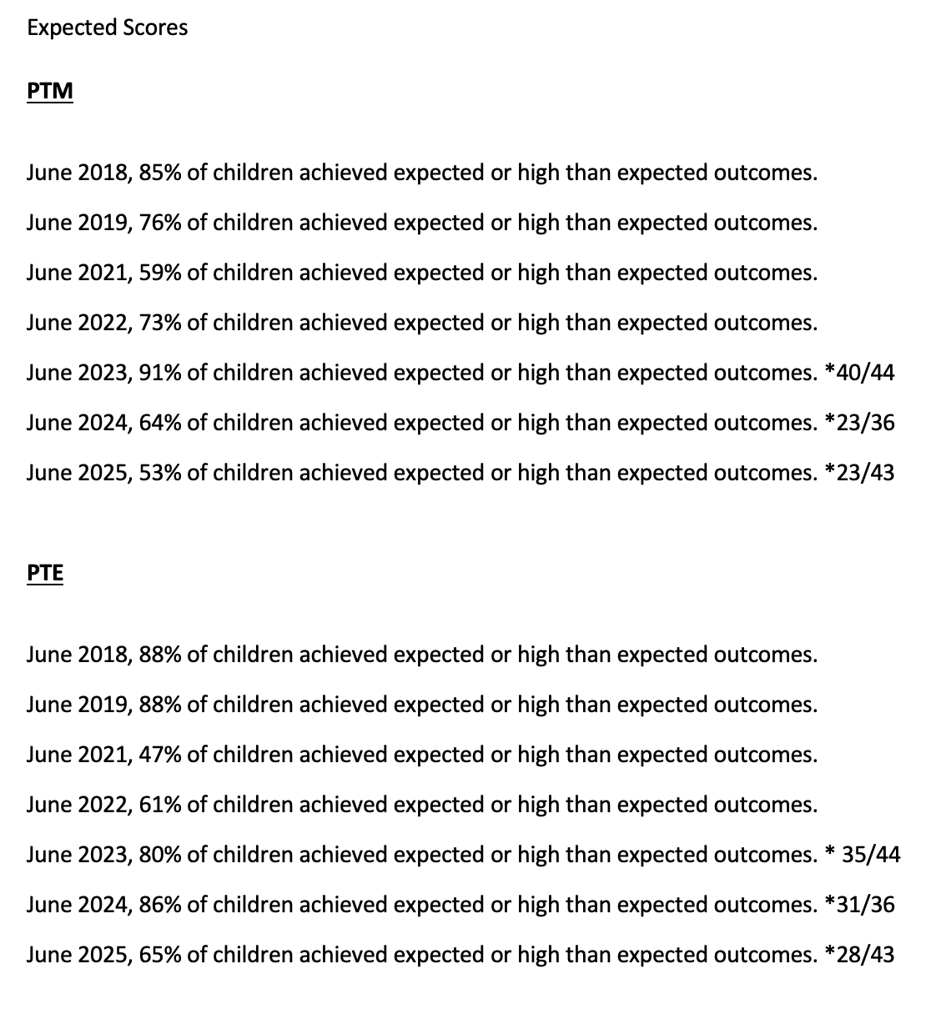

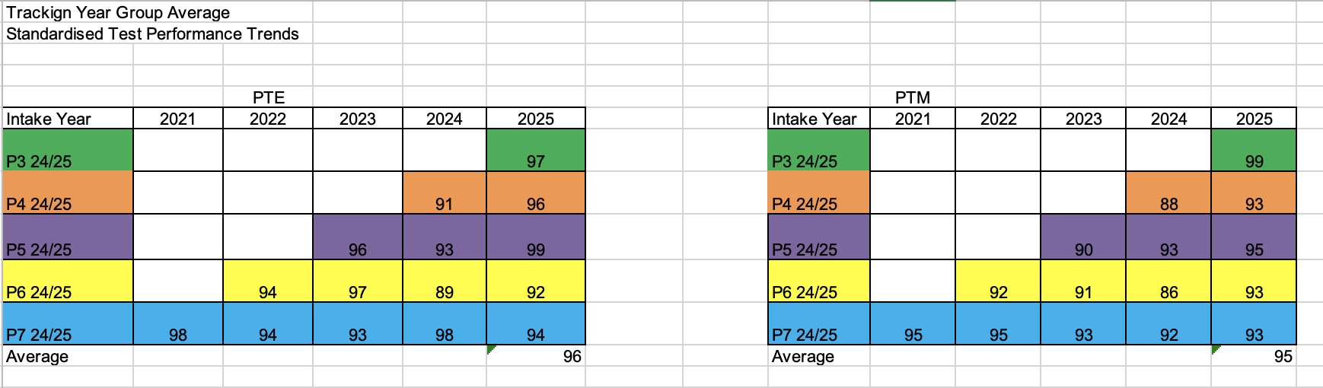

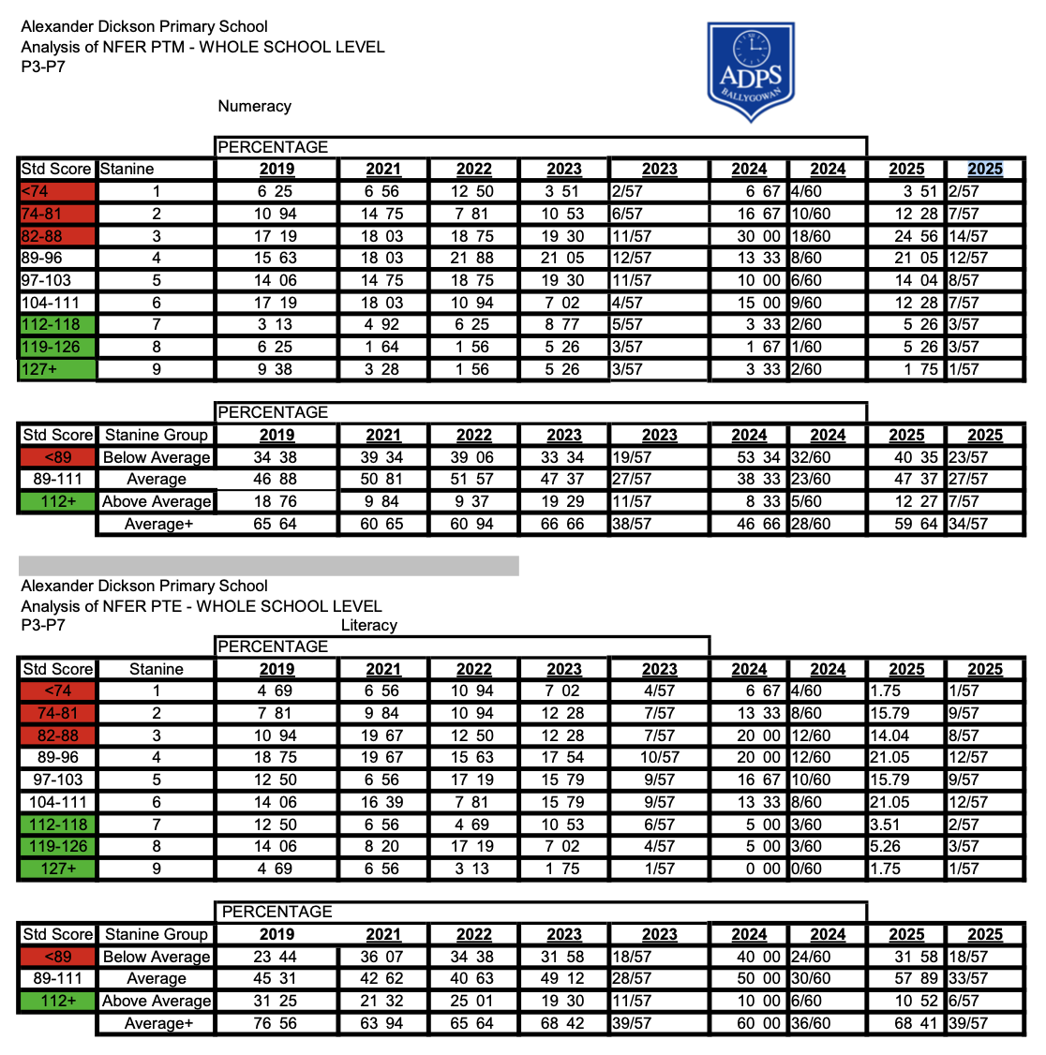

Evidence:
ETI Inspection Feedback (2024)

Inspection Summary Report -

A successful collaborative working relationship exists among all staff who are dedicated to promoting positive engagements within the school community and successfully create an attractive environment in which the children are ‘ready, respectful and safe’ in their learning.
Middle leaders, including those appointed recently, are enthusiastic and motivated to lead and coordinate their curricular areas of responsibility. They acknowledge that the monitoring and evaluation processes are at an early stage and recognise the importance of gathering first-hand evidence to measure the impact and progress of key priorities for development.
The staff know and understand the needs of the children very well. Through carefully considered approaches and strategies and tailored group and individual support, they meet effectively the needs of all of the children.
The behaviour of the children is exemplary; they engage positively with each other, settle quickly to learn, are confident and have well-developed self-management and independence skills.
The voice of the child is encouraged and valued by the staff which is exemplified in the modified child-friendly versions of key documents which broaden the children’s understanding of the areas for school improvement and how to stay safe.
The children have a great sense of pride in and belonging to their school and all stakeholders are committed to building and fostering a community of learning.
At the time of the inspection, the evidence provided by the school demonstrates that the arrangements for child protection align to the current statutory guidance.

Area for Action

To develop further the range of monitoring and evaluation processes to include the use of first-hand evidence to measure the progress and impact in addressing the key priorities for development.

Going Forward

The vibrant community spirit fostered in Alexander Dickson Primary School creates successfully a positive, welcoming environment in which all of the children are valued and participate actively in their learning.
Alexander Dickson Primary School is well placed to take forward the area for action detailed in the body of this report. Through DI engagement, the ETI will monitor the progress of the school in addressing the area for action.

Priorities 2025-2026

Mission Statement | Development  Area | Key Contributory Area(s) | Focus  (What) | Rationale  (Why)
"Our school builds relationships with kindness and honesty…” | Continuation of Shared Education | Curriculum for all ☒  Planning, Teaching and Assessment for Successful Learning ☒  Health, Wellbeing and Keeping Safe ☒  Equity, Diversity and Inclusion ☒  Environment, Society and Economy ☒  Digital Skills ☐  Staff Professional Learning ☒  Collaborative Networks ☒  Learner Participation ☒ | To enhance collaboration and learning opportunities between pupils and staff from Carrickmannon PS and St Mary’s PS through structured shared education programmes | Promote children’s mutual understanding, respect and inclusion  Develop joint curriculum projects that make learning more engaging, relevant and creative  Develop professional learning communities across schools through collaborative planning and sharing of best practice
"Our school builds relationships with kindness and honesty…”  "We will develop learning for life and work through effort and collaboration…” | Middle leaders:  monitoring and evaluation | Curriculum for all ☒  Planning, Teaching and Assessment for Successful Learning ☒  Health, Wellbeing and Keeping Safe ☒  Equity, Diversity and Inclusion ☒  Environment, Society and Economy ☒  Digital Skills ☐  Staff Professional Learning ☒  Collaborative Networks ☒  Learner Participation ☒ | Develop a whole-school approach to evidence-informed self-evaluation, incorporating:  - Direct observations of learning and teaching  - Pupil voice and engagement  - Work/book scrutiny  - Staff audits  - Embed these practices into strategic planning, subject leadership, and performance management cycles | To ensure that development priorities are accurately assessed and are based on authentic evidence  To build a culture of accountability and continuous improvement, where staff and pupils contribute meaningfully to evaluating what works  To enhance the school’s ability to demonstrate impact to stakeholders, including governors and parents  To support professional development by using first-hand evidence to identify strengths and areas for growth
“We encourage creativity, imagination and independence.”  “We will develop learning for life and work through  effort and collaboration…” | Literacy  Comprehension | Curriculum for all ☒  Planning, Teaching and Assessment for Successful Learning ☒  Health, Wellbeing and Keeping Safe ☒  Equity, Diversity and Inclusion ☒  Environment, Society and Economy ☒  Digital Skills ☐  Staff Professional Learning ☒  Collaborative Networks ☒  Learner Participation ☒ | Improve pupils’ reading comprehension skills and foster a love of reading through a consistent whole school approach:  - AR programme embedded effectively in P4-P7 with measurable pupil progress in reading age and comprehension  - Book bag system actively engaging P1-P3 pupils and families in reading at home  - Training programme for teaching and non-teaching staff to develop a shared understanding of comprehension, effective questioning and good practice  - Celebrate reading through events such as the Book Fair  - Evaluate impact through standardised assessment data and qualitative feedback | To develop pupils’ ability to understand, interpret and critically engage with texts  To build confident, independent readers prepared for the demands of the curriculum and beyond  To develop staff expertise to enhance classroom practice and promote a culture of professional growth and collaboration
“We will develop learning for life and work through  effort and collaboration…” | Numeracy  Mental maths | Curriculum for all ☒  Planning, Teaching and Assessment for Successful Learning ☒  Health, Wellbeing and Keeping Safe ☒  Equity, Diversity and Inclusion ☒  Environment, Society and Economy ☒  Digital Skills ☐  Staff Professional Learning ☒  Collaborative Networks ☒  Learner Participation ☒ | Improve pupils’ mental maths skills, confidence and fluency through a consistent whole school approach:  - Mental Maths Strategies are integrated into lessons across all year groups  - Digital platforms, Ten Town (P1-P3), Math Seeds (P1-P3) and Mathletics (P4-P7) are implemented effectively throughout the school  - Whole school participation in maths enrichment events like Number Day  - Staff demonstrate increased confidence in teaching mental maths, supported by CPD  - Mathematical vocabulary is used and modelled throughout the school | Mental Maths is a critical component of pupils’ overall numeracy skills and is the foundation for mathematical thinking  To build confident learners who can apply their mental maths skills to access more complex concepts  To develop staff expertise to enhance classroom practice and promote a culture of professional growth and collaboration
“We encourage creativity, imagination and independence.” | Pastoral  Positive behaviour and Discipline | Curriculum for all ☒  Planning, Teaching and Assessment for Successful Learning ☒  Health, Wellbeing and Keeping Safe ☒  Equity, Diversity and Inclusion ☒  Environment, Society and Economy ☒  Digital Skills ☐  Staff Professional Learning ☒  Collaborative Networks ☒  Learner Participation ☒ | Build understanding and consistency in a whole school culture of positive behaviour, emotional regulation and mutual respect | Emotional regulation is a foundational skill for mental health, behaviour and academic success  A consistent approach builds emotional literacy for the pupils and staff, supports resilience and develops a positive school culture

Summary of Planned Actions (How)

Priority | Year 1  2025-2026 | Year 2  2026-2027 | Year 3  2027-2028
Continuation of Shared Education | Develop meaningful partnerships with St. Mary’s PS and Carrickmannon PS to promote collaborative learning experiences  Prioritise health and well-being as a central theme in shared education activities  Plan and deliver joint events and trips that foster inclusion, respect, and mutual understanding among pupils and staff  Success Criteria:  - Joint planning meetings held to agree on themes, goals, and logistics  - Health and Well-being Focus embedded  - Shared education activities include a clear focus on emotional, social, and physical well-being  - Pupils engage in joint workshops or sessions on topics such as friendship, resilience, and healthy lifestyles  - Staff collaborate on well-being strategies and share good practice  - Joint trips and events organised  - At least five shared trips or events take place during the year.  - Activities are inclusive, purposeful and linked to curriculum or well-being goals  - Pupil feedback is gathered to evaluate impact and inform future planning  - Evidence of participation and impact is collected (photos, pupil voice, staff reflections)  - Coordinators maintain a shared education file with planning, evaluations, and next steps | Continue to embed meaningful partnerships with St. Mary’s PS and Carrickmannon PS to promote collaborative learning experiences  Prioritise health and well-being as a central theme in shared education activities  Plan and deliver joint events and trips that foster inclusion, respect, and mutual understanding among pupils and staff  Success Criteria:  - Joint planning meetings held to agree on themes, goals, and logistics  - Health and Well-being Focus embedded  - Shared education activities include a clear focus on emotional, social, and physical well-being  - Pupils engage in joint workshops or sessions on topics such as friendship, resilience, and healthy lifestyles  - Staff collaborate on well-being strategies and share good practice  - Joint trips and events organised  - At least five shared trips or events take place during the year.  - Activities are inclusive, purposeful and linked to curriculum or well-being goals  - Pupil feedback is gathered to evaluate impact and inform future planning  - Evidence of participation and impact is collected (photos, pupil voice, staff reflections)  - Coordinators maintain a shared education file with planning, evaluations, and next steps  - End-of-year review conducted to assess progress and identify development areas for 2026-2027 | Continue to meaningful partnerships with St. Mary’s PS and Carrickmannon PS to promote collaborative learning experiences  Prioritise health and well-being as a central theme in shared education activities  Plan and deliver joint events and trips that foster inclusion, respect, and mutual understanding among pupils and staff  Success Criteria:  - Joint planning meetings held to agree on themes, goals, and logistics  - Health and Well-being Focus embedded  - Shared education activities include a clear focus on emotional, social, and physical well-being  - Pupils engage in joint workshops or sessions on topics such as friendship, resilience, and healthy lifestyles  - Staff collaborate on well-being strategies and share good practice  - Joint trips and events organised  - At least five shared trips or events take place during the year.  - Activities are inclusive, purposeful and linked to curriculum or well-being goals  - Pupil feedback is gathered to evaluate impact and inform future planning  - Evidence of participation and impact is collected (photos, pupil voice, staff reflections)  - Coordinators maintain a shared education file with planning, evaluations, and next steps
Middle leaders:  monitoring and evaluation | Build capacity and consistency in leadership monitoring practices  Success Criteria:  - Coordinator files are in place for all key areas  - Subject leaders have written action plans aligned with school priorities  - A whole-school monitoring and evaluation calendar is developed and shared  - Coordinators receive training on:  - Their strategic role  - Gathering and using first-hand evidence (e.g. observations, pupil voice, work scrutiny)  - Initial monitoring activities agreed at a whole staff level  - Evidence of monitoring to be recorded in coordinator files  - Coordinators present findings to Principal and key governors throughout the year | Embed first-hand evidence into regular review and planning cycles  Success Criteria:  - Coordinators lead termly monitoring activities using a range of first-hand evidence  - Evidence is used to evaluate progress against action plans and inform next steps  - Staff engage in peer observations and reflective dialogue  - CPD supports deeper understanding of impact measurement and triangulation of evidence | Evaluate the effectiveness of monitoring systems and refine for sustainability  Success Criteria:  - Coordinators demonstrate clear impact of actions through evidence-informed evaluations  - Monitoring outcomes directly inform school improvement planning  - A culture of shared accountability and professional inquiry is evident across the school  - Systems are reviewed and refined based on feedback and outcomes  - Good practice is shared internally and externally (e.g. clusters)
Literacy  Comprehension | Improve pupils’ reading comprehension skills and foster a love of reading through a consistent whole school approach  Success Criteria  - AR programme embedded effectively in P4-P7 with measurable pupil progress in reading age and comprehension  - Clear Testing Schedule for Assessments including STAR Reader, PTE, CAT4, CCEA Adaptive Assessments  - Book bag system put in place; books and bags purchased and organised  - Training programme for teaching and non-teaching staff to develop a shared understanding of comprehension, effective questioning and good practice  - Reading celebrated through events - including the Book Fair, assemblies, displays  - Evaluate impact through standardised assessment data and qualitative feedback | Improve pupils’ spelling accuracy and consistency across all year groups by implementing a whole school approach to spelling instruction | Improve pupils’ spelling accuracy and consistency across all year groups by implementing a whole school approach to spelling instruction
Numeracy  Mental maths | Improve pupils’ mental maths skills, confidence and fluency through a consistent whole school approach.  Success Criteria  - Mental Maths Strategies are integrated into lessons across all year groups.  - Use digital platforms Ten Town (P1-P3), Math Seeds (P1-P3) and Mathletics (P4-P7) effectively throughout the school  - Whole school participation in maths enrichment events like Number Day  - Training programme for teaching and non-teaching staff to develop increased confidence in teaching mental maths, supported by CPD  - Mathematical vocabulary is used and modelled throughout the school  - Evaluate impact through standardised assessment data and qualitative feedback | To improve pupils’ problem solving skills by embedding mental maths strategies across the whole school. | To improve pupils’ problem solving skills by embedding mental maths strategies across the whole school.
Pastoral  Positive behaviour and Discipline | Build understanding and consistency in a whole school culture of positive behaviour, emotional regulation and mutual respect  Success Criteria:  - Develop a consistent, whole school approach to emotional regulation that empowers pupils to recognise, understand and manage their emotions  - Develop and display emotional regulation visuals in all classrooms and shared areas  - Whole school staff training with Eden Consultancy in ‘Understanding Behaviour’ and ‘Supporting pupils with stress and anxiety.’  - Staff feel confident supporting pupils who display dysregulated behaviours and low-level disruption  - Clear focus on employing pupil voice through school with key roles including eco council, school council | Embed whole school culture of positive behaviour, emotional regulation and mutual respect  Success Criteria:  - Embed consistent, whole school approach to emotional regulation that empowers pupils to recognise, understand and manage their emotions  - Embed regulation tools into relevant pastoral policies  - Evidence is used to evaluate progress against action plans and inform next steps  - Staff and pupils engage in reflective dialogue and surveys  - Celebrate progress through wellbeing displays, class/whole school rewards and assemblies | Evaluate the effectiveness of positive behaviour, emotional regulation and mutual respect  Success Criteria:  - A culture of shared accountability and professional inquiry is evident across the school  - Pupils’ ability to regulate emotions and engage with learning reviewed and refined based on feedback and outcomes  - Good practice is shared internally and externally (e.g. clusters)  - Refresher training for new staff and deeper CPD for experienced staff

Low level priorities
‘Quick Wins’
Area | Target | Leader
Leadership and Management | New Principal to attend the First-Time Principals’ Programme to support leadership development and strategic school improvement  Newly reconstituted Board of Governors to engage in a structured training programme to strengthen governance and strategic oversight | L Shaw  L Shaw
Eco Schools /Outdoor learning | Embed good practice from last year  Create an Eco Committee  Staff to receive Level 1 Forest Schools Training  3 staff members to receive Level 3 | C Farquhar  L Shaw
The Arts | Continue to develop the school choir through regular rehearsals, Musical Thursday Afternoons P4-P7, performance opportunities, and increased pupil participation  Plan and deliver a musical production to showcase pupils’ talents and enhance creative learning experiences  Whole School Trip to the Pantomime. | L Wightman  All staff
Accommodation | Collaborate with the PTA to design and implement new playground markings and equipment that enhance outdoor play and learning opportunities | L Shaw  C Farquhar  J Shanks  PTA
Wrap around Care | Explore the establishment of structured after-school care provision to support working families and enhance wraparound support for pupils | L Shaw
Pre-school links | Continue pre-school gymnastics and reading buddies and extend pre-school links to include forest school activities | M Nield  C Farquhar

